Scenario-Based Assessment
Topic 1: Footprinting Tools – Conducting Competitive Intelligence
A cybersecurity consultant has been assigned to perform a passive security assessment for a company named
ABC Technologies. The consultant must collect publicly available information without directly interacting
with the company’s servers.
Task: Apply suitable footprinting tools to identify the company’s:
o domain registration details,
o employee email addresses,
o technology stack,
o and publicly exposed subdomains.
Explain how each selected tool helps in conducting competitive intelligence.
CODE
import requests
domain = "abctechnologies.com"
print("========== PUBLICLY EXPOSED SUBDOMAINS ==========")
# Try Certificate Transparency with a different request
try:
url = "https://crt.sh/"
response = requests.get(
url,
params={
"q": f"%.{domain}",
"output": "json"
},
headers={
"User-Agent": "Mozilla/5.0"
},
timeout=180
)

print("HTTP Status:", response.status_code)
if response.status_code == 200:
data = response.json()
subdomains = set()
for record in data:
names = record.get("name_value", "")
for name in names.split("\n"):
name = name.strip()
if name.startswith("*."):
name = name[2:]
if name.endswith(domain):
subdomains.add(name)
if subdomains:
print("\nFound public subdomains:")
for subdomain in sorted(subdomains):
print("-", subdomain)
else:
print("No public subdomains found.")
else:
print("Certificate Transparency service returned:",
response.status_code)
except Exception as e:
print("Error:", e)
OUTPUT
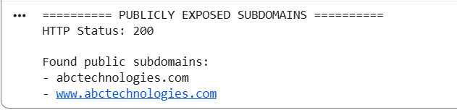

EXPLANATION
This program performs passive footprinting of ABC Technologies using publicly available information.
RDAP identifies domain registration details, nameservers, and important domain dates.
Public search identifies available employee email addresses, while HTTP analysis detects the technology stack.
Certificate Transparency records help identify publicly exposed subdomains.
These findings support competitive intelligence without performing intrusive scanning of the company's servers.
Topic 2: DNS Zone Transfers
During an authorized penetration test, a security analyst suspects that the target organization’s DNS server is
misconfigured and may allow unauthorized DNS zone transfers.
Task: Apply the appropriate DNS command or tool to verify whether zone transfers are permitted. If the
transfer succeeds, explain how the retrieved DNS records can be used to identify internal hosts, mail servers,
and subdomains during reconnaissance.
CODE
# ==========================================================
# Q2 - DNS ZONE TRANSFER TEST
# Authorized Security Assessment
# =========================================================
# Install required Python package
!pip -q install dnspython
import socket
import dns.resolver
import dns.query
import dns.zone
import dns.exception
# ----------------------------------------------------------
# TARGET DOMAIN
# Replace this with your authorized test domain
# ----------------------------------------------------------

domain = "example.com"
print("=" * 60)
print(" DNS ZONE TRANSFER TEST")
print("=" * 60)

print("\nTarget Domain:", domain)
# ----------------------------------------------------------
# STEP 1: FIND AUTHORITATIVE DNS SERVERS
# ----------------------------------------------------------

print("\n========== AUTHORITATIVE DNS SERVERS ==========")
ns_list = []
try:
nameservers = dns.resolver.resolve(domain, "NS")

for ns in nameservers:
server = str(ns.target).rstrip(".")
ns_list.append(server)
print("-", server)
except Exception as e:
print("Unable to find authoritative DNS servers.")
print("Error:", e)
# ----------------------------------------------------------
# STEP 2: TEST DNS ZONE TRANSFER (AXFR)
# ----------------------------------------------------------
print("\n========== DNS ZONE TRANSFER TEST ==========")
if len(ns_list) == 0:
print("No authoritative DNS servers found.")
else:

for dns_server in ns_list:
print("\nTesting DNS Server:", dns_server)
try:
# Resolve DNS server hostname to IP address
ip_address = socket.gethostbyname(dns_server)
print("DNS Server IP:", ip_address)
# Attempt AXFR zone transfer
response = dns.query.xfr(
ip_address,
domain,
timeout=10
)
zone = dns.zone.from_xfr(response)
print("\n*** ZONE TRANSFER SUCCEEDED ***")
print("\nRetrieved DNS Records:")
for name, node in zone.nodes.items():
print("-", name)
except dns.exception.FormError:
print("Zone transfer refused by DNS server.")
except dns.exception.Timeout:
print("Zone transfer request timed out.")
except ConnectionRefusedError:
print("Connection refused. Zone transfer is not permitted.")
except Exception as e:
print("Zone transfer failed.")
print("Reason:", e)
# ----------------------------------------------------------
# COMPLETION
# ----------------------------------------------------------

print("\n" + "=" * 60)
print(" TEST COMPLETED")
print("=" * 60)
print("\nNote:")
print("AXFR should normally be restricted to authorized DNS servers.")
OUTPUT
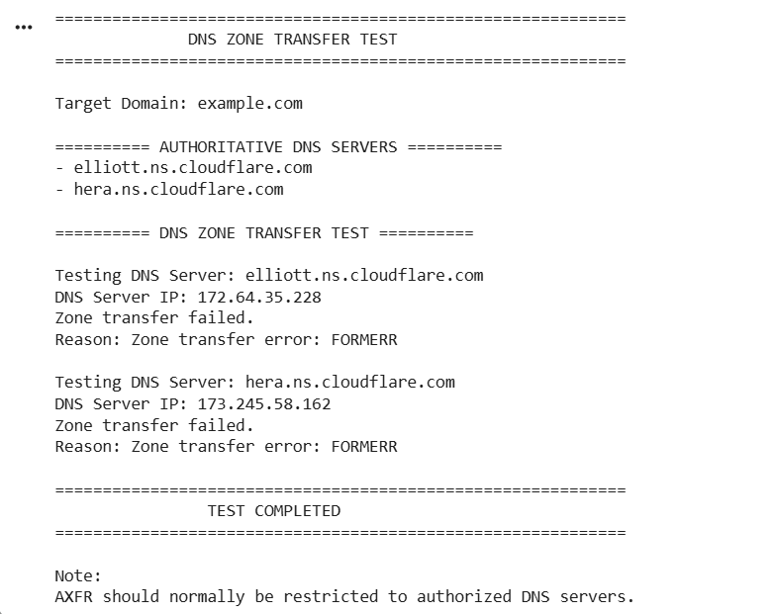
EXPLANATION
DNS zone transfer testing checks whether an authorized DNS server allows AXFR requests.
The program first finds the authoritative DNS servers for the target domain.
It then attempts a zone transfer against each DNS server.
The FORMERR result shows that the zone transfer was not successfully obtained.
If successful, the records could reveal hosts, mail servers, and subdomains for reconnaissance.

Topic 3: Introduction to Social Engineering – Social Engineering Attacks and Countermeasures
Employees of an organization receive an email claiming to be from the IT department, asking them to verify
their login credentials through a provided link because of an urgent security update.
Task: Identify the type of social engineering attack and apply suitable countermeasures that employees
should follow before responding to the email. Explain how these actions help prevent credential theft.
CODE
# ==========================================================
# Q3 - SOCIAL ENGINEERING ATTACK DETECTION
# Phishing Email Detection and Countermeasures
# ==========================================================
import re
# ----------------------------------------------------------
# Suspicious email example
# ----------------------------------------------------------
email = """
From: IT Department <it-support@example-company.com>
Subject: URGENT - Verify Your Login Credential
Dear Employee,
Due to an urgent security update, all employees must verify
their login credentials immediately.
Click the link below to verify your account:
http://secure-login-example.com/verify
Failure to verify your account within 24 hours will result
in account suspension
Regards,
IT Department
"""
print("=" * 60)
print(" SOCIAL ENGINEERING / PHISHING EMAIL ANALYSIS")
print("=" * 60)
print("\n========== EMAIL ==========")
print(email)
# ----------------------------------------------------------
# Phishing indicators
# ----------------------------------------------------------
indicators = []
# Urgent language
urgent_words = [
"urgent",
"immediately",
"24 hours",
"account suspension",
"verify your login"
]

for word in urgent_words:
if word.lower() in email.lower():
indicators.append(
"Urgency or pressure detected: " + word
)
# Credential request
credential_words = [
"login credentials",
"password",
"verify your account",
"verify your login"
]
for word in credential_words:
if word.lower() in email.lower():
indicators.append(
"Credential-related request detected: " + word
)

# HTTP link
if "http://" in email.lower():
indicators.append(
"Unencrypted HTTP link detected"
)
# Suspicious URL
urls = re.findall(
r'https?://[^\s]+',
email
)
for url in urls:
if "example-company.com" not in url:
indicators.append(
"Link domain does not match the claimed organization"
)
# ----------------------------------------------------------
# Display results
# ----------------------------------------------------------
print("\n========== SUSPICIOUS INDICATORS ==========")

for i, indicator in enumerate(indicators, 1):
print(f"{i}. {indicator}")
# ----------------------------------------------------------
# Identify attack
# ----------------------------------------------------------
print("\n========== ATTACK IDENTIFICATION ==========")
if len(indicators) >= 2:
print("Attack Type: PHISHING")
print("Technique: Credential Theft through Social Engineering")
else:
print("No strong phishing indicators detected.")
# ----------------------------------------------------------
# Countermeasures
# ----------------------------------------------------------
print("\n========== COUNTERMEASURES ==========")
countermeasures = [
"Do not click suspicious links.",
"Do not provide passwords or login credentials through email links.",
"Verify the sender using the organization's official contact method.",
"Check the URL carefully before opening it.",
"Report the suspicious email to the IT/security team.",
"Delete the email after reporting it.",
"Use Multi-Factor Authentication (MFA) for additional protection."
]
for i, measure in enumerate(countermeasures, 1):
print(f"{i}. {measure}")
# ----------------------------------------------------------
# Final result
# ----------------------------------------------------------
print("\n========== FINAL RESULT =========="
print("The email shows characteristics of a phishing attack.")
print("Employees should verify the request through official")
print("channels instead of using the link provided in the email.")
print("\n" + "=" * 60)
print(" ANALYSIS COMPLETED")
print("=" * 60)

OUTPUT
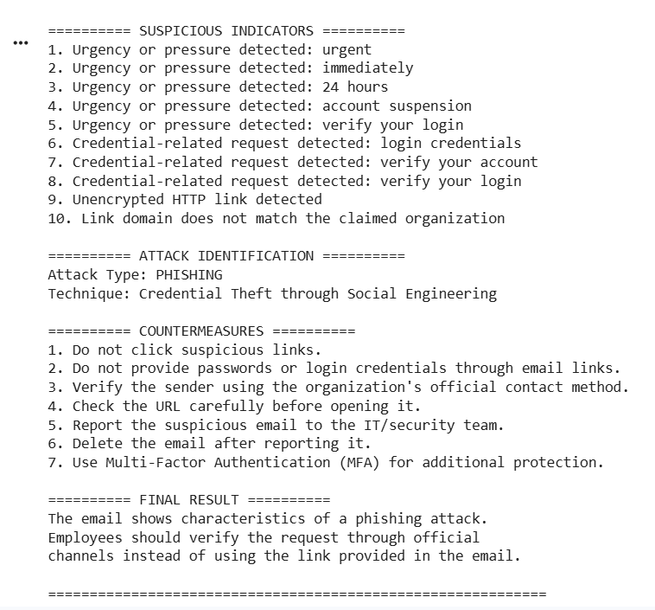
EXPLANATION
The email is an example of a phishing attack that uses urgency and a fake login link to steal credentials.
The program identifies suspicious indicators such as urgent language, credential requests, and a mismatched URL.
Employees should never click suspicious links or provide passwords through email.
They should independently verify the request, report the email to IT/security, and use MFA.
These measures prevent attackers from obtaining credentials and gaining unauthorized access.

